|  |  |  |
| --- | --- | --- |
| 3C2 Digital Circuits | October 21  LAB D1 | |
| Alexandru Sulea Student No: 123152 Student e-mail: suleaa@tcd.ie | | Junior Sophister |

**Laboratory D1: The Bipolar Junction Transistor Inverter**

**Introduction :**

The purposes of the following experiments are firstly to introduce students to the use of the industry-standard circuit simulation package MultiSim, and secondly to examine some of the properties of the Bipolar Junction Transistor or BJT, which have been discussed in lectures.

Although now subject to intense competition from the metal-oxide semiconductor field effect transistor (MOSFET), the bipolar junction transistor (BJT) has, for a long time, been the principal active electronic device for both analogue and digital applications and remains so today in circuits using discrete transistors, such as in the automotive industry. In this experiment, through the National Instruments MultiSim analysis package we investigate:

1. the current - voltage characteristics of a BJT,
2. the input - output voltage transfer characteristics of a simple BJT inverter, and
3. the dynamic properties ( i.e. switching speed ) of the BJT inverter.

MultiSim has a built-in library of software models for many readily available discrete transistors - we use one such model for the **2N2222 BJT**. The further objective will be to compare the results of our computer simulation and measurements with data calculated from basic transistor circuit theory.

**A. BJT Current - Voltage Characteristics.**

In this part of the experiment, we treat the transistor as an individual device and examine its current - voltage relationships.

**A.1 Collector Current against Base - Emitter Voltage.**

The circuit to be assembled is as shown in the following figure.

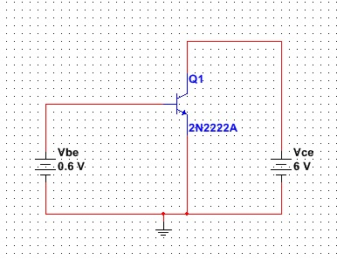

‘ALL SELECTIONS IN WINDOWS AND IN SCHEMATICS ARE DONE USING THE LEFT MOUSE BUTTON UNLESS STATED OTHERWISE’

The following are the instructions required to construct a schematic and simulate the behaviour of the above circuit.

**Schematic Entry:**

1): Begin by opening the NI MultiSim application. You will be presented with a blank grid sheet upon which to construct the circuit.

2): Locate the 2N222A transistor by clicking **Place>Component** and typing the transistor model number into the ‘**Component:**’ box in the window which appears. Click **OK**. The window will disappear and the component will appear at the mouse cursor. Click anywhere on the grid to place the part.

3): When you place the transistor, the component dialogue box will reopen. Click ‘**close**’ for now.

4): Next, click on the transistor once (with the left mouse button), a dashed box will appear around it. Then Right-Click and select **Properties>Edit component in DB**. Navigate to the ‘**Model**’ tab. Here you will find a text window containing the model data. From the list write the following parameters in the table below (TIP: Click in the data window and press ‘ctrl+a’ to select all, followed by ‘ctrl+c’ to copy. Open notepad and press ‘ctrl+v’ to pass the data into the text editor where it will be easier to read). Note the units.

Parameters taken from component 2N2222A:

|  |  |
| --- | --- |
| Bf, the forward gain (βF) | 220 |
| Br, the reverse gain (βR) | 4 |
| Tf, the forward transit time (τF) | 0.325ns |
| Tr, the reverse transit time (τR) | 100ns |
| Cjc, B-C zero-bias depletion capacitance (CBC) | 9.12pF |
| Cje, B-E zero-bias depletion capacitance (CBE) | 27.0pF |

Once you have all the values, click ‘**Cancel**’ to close the database window.

5): Following the same procedure as above, open the **Components dialogue** and type in **‘DC_POWER’** to get a dc voltage source from the libraries. Place one source to the left of the transistor by pressing the left mouse button and one to the right in the same way.

6): The default voltage value of the each source is 0V. You need to change the voltage of the source to be connected to the base to **0.6V**. To do this, double click on the voltage of the voltage source to be connected to the base of the transistor. This calls up the **‘Value’** dialogue box where you can make it 0.6V. In the same dialogue, navigate to the ‘**Label**’ tab and change the ‘**RefDes**’ to ‘**Vbe**’.

Similarly change the value and name of the voltage source to be connected to the collector of the transistor to **6V** and **Vce** respectively. Click OK and observe the name changes in the drawing.

7): To wire the components together, simply click on any one of the available terminals on any of the components and draw a line to the appropriate connection point.

8): **Important step here !** You must include a GROUND symbol in the circuit. To find it, go to **Place**>**Component** and type in ‘**Ground**’. Wire this into your ground reference line (the zero volts rail) of the circuit.

9): Save your circuit schematic giving it a suitable name.

**Simulation Set-Up:**

10): Now, you must set up the simulation. Navigate in the menu toolbar to **Simulate>Analyses>DC Sweep**. Setup your DC Sweep analysis parameters as shown below and then click on the ‘**Output**’ tab.

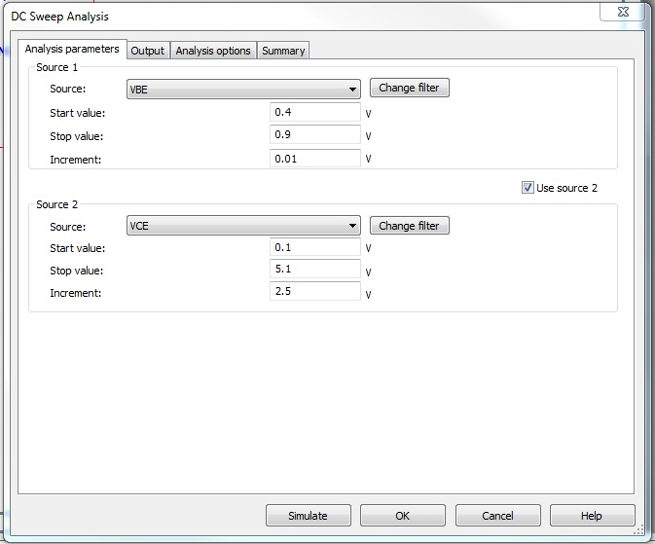

11): Select ‘**Add expression**’ and select ‘**I(Vce)**’ from the variables list in the window which appears. This provides a probe which will monitor the current associated with collector-emitter voltage across the transistor. Click ‘**Copy Variable to expression**’ and, in the expression bar, place a ‘**-**‘before **I(Vce)**. This ensures that the current is measured in the direction flowing into the collector of the transistor. Click ‘**OK**’. The window will close and you should be left with the same configuration as is shown below.

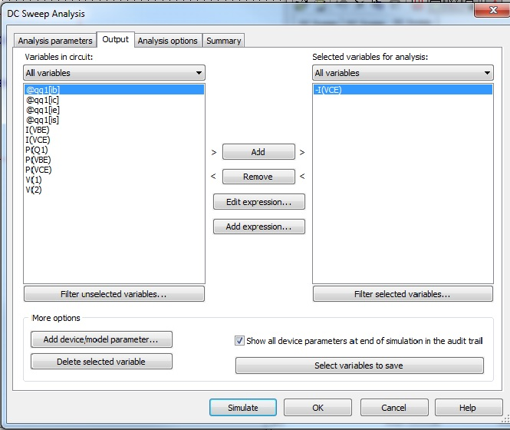

**Running a Simulation:**

12): Click ‘**Simulate**’.

When the circuit is simulated, three plots of **IC** versus **Vbe** will be produced for the three values of **Vce**, namely:

**Vce = 0.1V** Transistor Saturated.

**Vce = 2.6V** Transistor in the Forward Active Region.

**Vce = 5.1V** Transistor in the Forward Active Region.

12): Print out or save your plots for inclusion in your laboratory report.

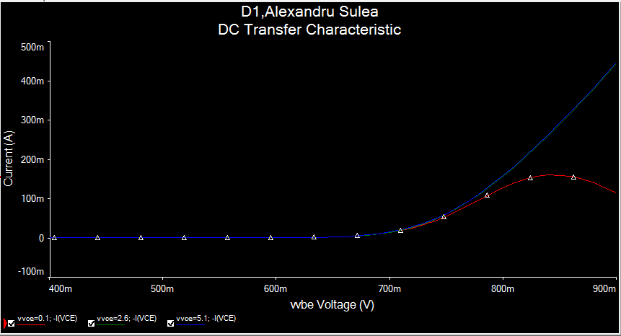

13): Click the **Show Cursors** icon on the toolbar to display the cursors on the plot along with a data point window. The cursors can be moved along the plot to any point of interest using the mouse.

Use one of the cursors to measure **Vbe cut-in** when **Ic = 100µA** and **Vbe on** when **Ic = 5mA**.

|  |  |
| --- | --- |
| **Vbe cut-in** | 0.781V |
| **Vbe on** | 0.671V |

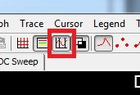

How does **Vbe sat** compare with **Vbe on**?

**A.2 Collector Current vs. Collector-Emitter Voltage.**

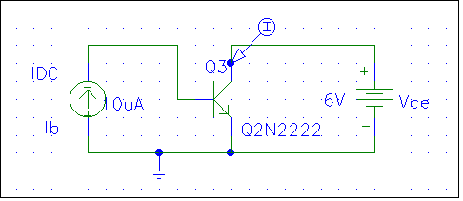

1): Re-using the previous circuit, click once on the base-emitter voltage source, **Vbe** and hit **DELETE** on the keyboard to remove it. In the **Components List** type in **‘DC_CURRENT’**. Click ‘**OK**’ and a current source will replace the mouse pointer. Use ‘**ctrl+r**’ to rotate the component if required and then simply click to place it. Make sure that it is connected into the circuit, rewiring connections as necessary. Close the components dialogue.

2): Set the current source value to **10uA** by double clicking on its value and editing the **‘Value’** dialogue box. Rename it to ‘**Ib**’ using the label tab.

3): From the Menu bar call up the DC Sweep analysis window again (**Simulate>Analyses>DC Sweep**) and set up the sweep parameters as shown below.

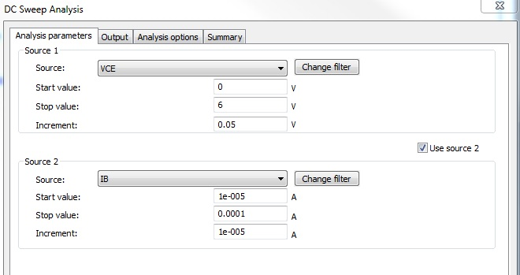

4): Simulate the circuit as before. If there are no errors, the plot should open up and ten curves should be displayed.

5): Each of the curves represents one value of **Ic** plotted against **Vce** with **Ib** ranging from **10μA** to **100μA**. The following approximation can be assumed relating **Ic** to **Ib**.



Using this equation and the plots, calculate and record the following:

|  |  |
| --- | --- |
|  | 2500 |
|  | 210 |
|  | 0.246619 V |

Print out or save the plots obtained for inclusion in your laboratory report.

6): Returning to the circuit, delete the transistor by clicking on it once and hitting Delete. From the component library call up the transistor **‘2N3904’** and insert it where the **‘2N2222’** was placed previously. Replace any deleted wires, re-run the simulation and compare the results.

|  |  |
| --- | --- |
|  | 142 |
|  | 162 |
|  | 0.217414 V |

Print out or save the plots obtained for inclusion in your laboratory report.

**B. Resistive Loaded BJT Inverter - Transfer Characteristic.**

The objective here is to plot the output voltage, Vo against the input voltage, Vi for a simple single-transistor BJT inverter and to compare the main points of interest with what is expected from theory.

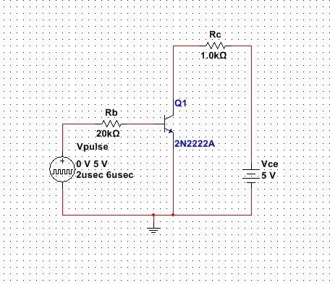

1): Start a completely new project with a new name and construct the circuit shown above.

Note that the stimulus source for this circuit is a pulse module and its part name is **‘PULSE_VOLTAGE’**. The resistors above appear as ‘**RESISTOR_RATED**’ in the catalogue.

Ensure that the appropriate labels are given to all elements and that each elements has the appropriate value.

2): Double click on the wire segment which connects ‘**Vpulse**’ to ‘**Rb**’.

In the ‘**Preferred net name:**’ box, enter ‘**Vi**’

Double click on the wire segment connecting the collector of ‘**Q1**’ to ‘**Rc**’.

In the ‘**Preferred net name:**’ box, enter ‘**Vo**’

3): Double click on the **Vpulse** component to bring up its properties dialogue box. Set up the device with the parameters shown below.

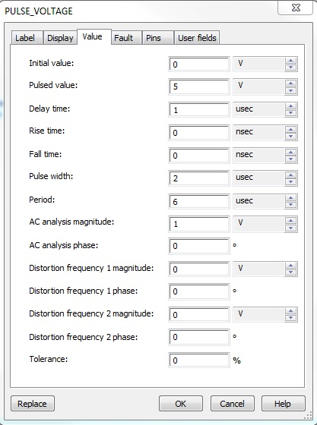

4): Call up **DC Sweep** again and setup the analysis parameters as shown below

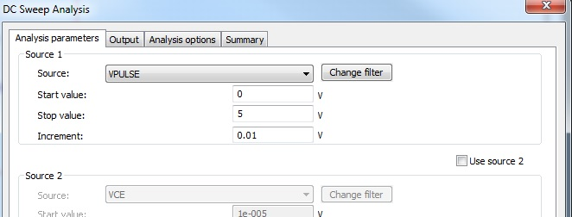

Select the Output tab and ‘**Add**’ the parameters ‘**V(Vi)**’ and ‘**V(Vo)**’ to the ‘**Selected variables for analysis**’ column (highlight them in the column on the left and click ‘**Add**’).

5): Now simulate the circuit and, provided there are no errors, the **‘PROBE’** program should open up and display a plot of **Vo** against **Vi**.

6): Using the cursors again, record the values illustrated in the diagram below:



|  |  |
| --- | --- |
| **VOH** | 5V |
| **ViL MAX** | 0.530V |
| **VOL** | 0.291V |
| **ViH MIN** | 1.1337V |

Print out or save the plot obtained for inclusion in your report.

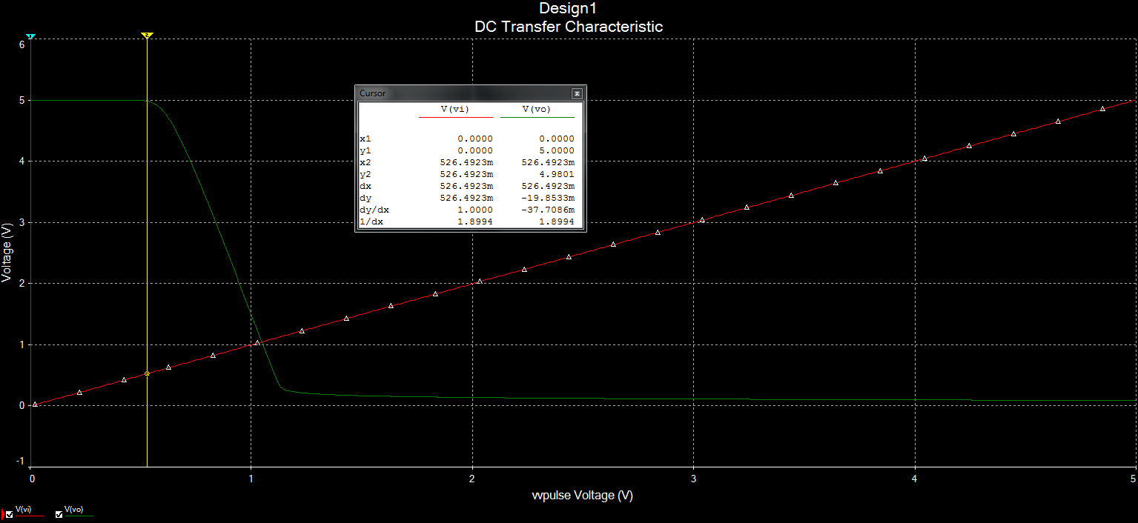

7): Compare these measurements with calculations from theory and previous device measurements:

5V

0.291V

0.530V

1.0990V

8): Predict what will happen if **Rc** is increased from **1kΩ** to **4kΩ**.

Ans. Quicker Decay in the wave form.Eg. steeper decline noticed in wave

9): Having closed down the graph, change the value of **Rc** to **4kΩ**.

Re-run the simulation to investigate and record what happens to the transfer characteristic.

Print out the plot obtained for inclusion in your report.

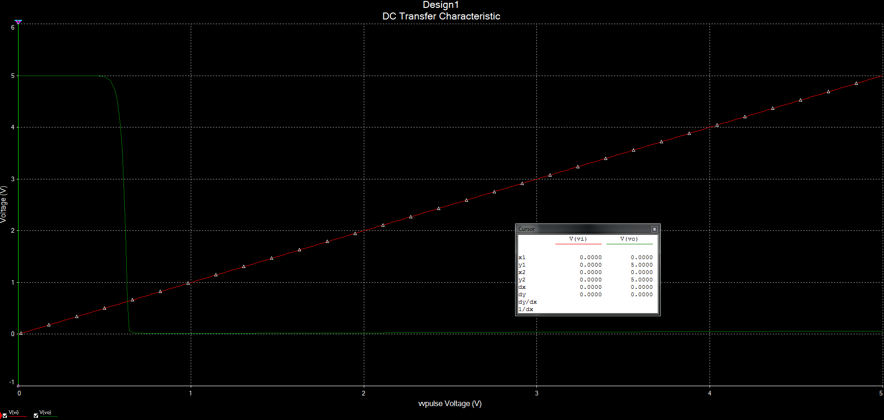

**C. BJT Inverter - Switching Characteristics**

Re-using the same schematic as in section B, we now drive this circuit with an ideal pulse waveform and examine the resulting output waveform. Specifically we are interested in





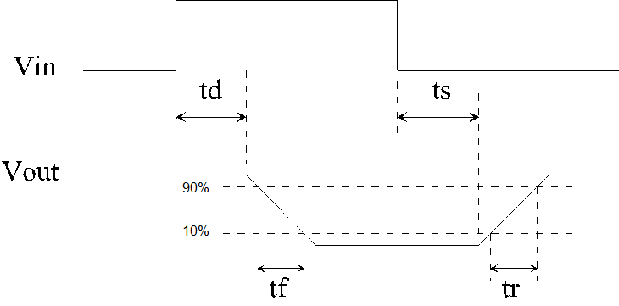

These switching times are to be measured and the results compared with the values derived from analytical expressions similar to those obtained in the lectures.

1): With the circuit as previously configured (**Rb =20kΩ, Rc =1kΩ** ). Navigate to **Simulate>Analyses>Transient analysis**. Set up the analysis to apply a **6µs** run time and a **12ns** maximum time step as shown below.

Check the ‘**Output**’ tab so see that ‘**V(vin)**’ and ‘**V(vo)**’ are still entered. If they are not, then add them as before.

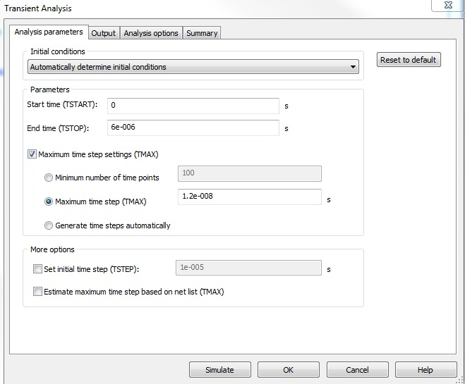

2): Click ‘**Simulate**’ and in the graph that appears and use the cursors to measure the following values.

|  |  |
| --- | --- |
|  | 0.0796us |
|  | 0.1293us |
|  | 0.1642us |
|  | 0.592us |

3): Compare the measured values with those calculated from the following analytical equations. You will need the properties recorded for the transistor from the database in the first task carried out in Section A1.

0.0809us

0.0809us





=1.4855X10-7

where 

2.1645X10-4 A



4.709X10-3 A

Then





7.411X10-7 s

where 

-3.355X10-5 A





4.905X10-5 A

Finally



3.827X-10 s

Fill the appropriate values as calculated from the above equations into the following table.

|  |  |
| --- | --- |
|  | 8.09X10-8s |
|  | 1.4855X10-7s |
|  | 7.411X10-7s |
|  | 3.827X10-5 s |

The calculated values should be compared with the measured values obtained in the simulation above.

4): Predict what will happen if **Rb** is reduced to **5kΩ** (without calculations).

5): Change **Rb** in the circuit to **5kΩ** and investigate and record the resulting effects.

|  |  |
| --- | --- |
|  | 2.0236X10-8 s |
|  | 5.743X10-8 s |
|  | 1.423X10-6 s |
|  | 5.855X10-8 s |

6): Predict what will happen if **Rc** is increased to **4kΩ** (without calculations).

Since Rc is responsible for the value of ICMAX a higher value for Rc will mean a decreased value of ICMAX thus giving a smaller value for every time across the board except for td  since it is not effected by ICMAX  or Rc

7): Change **Rc** in the circuit to **4kΩ** and investigate and record the resulting effects in the table below.

ANS.

The results achieved were taken as only Rc being changed and not Rc together with Rb since reading the Q does not specify specifically at which point to increase RC.

|  |  |
| --- | --- |
|  | **8.094X-8 s** |
|  | **1.162X10-7 s** |
|  | **9.8435X10-5 s** |
|  | **9.550X 10-7 s** |

**Laboratory Report:**

You are required to write up a properly structured report on these experiments according to the overall guidelines issued with the laboratory schedule. The report should briefly summarise the procedure (not the step-by-step detail), present the results including the plots of graphs or waveforms and/or tables of data, draw suitable conclusions and discuss them for each task carried out as part of the experiment:

A: BJT Current-Voltage Characteristics

B: BJT Inverter Transfer Characteristic

C: BJT Inverter Switching Characteristics

In the report you should show clearly that you can interpret the results obtained from the experiment you have carried out. In your discussion you should relate them to lecture material where possible as well as to real-life applications you feel they may have relevance to. You should attempt to explain any divergences between the predicted or expected values and the measured values obtained from simulations. You should also make an attempt to show that you understand the importance of your experiment and the results obtained in the wider context of Electronic Engineering. Some issues for consideration in this regard might be:

1. What are the limitations on the accuracy of your results?

Human error played a big part in discerning the results as subjective viewing was used more than accurate measurement.

1. How do the values of parameters compare with those obtained in lectures?
2. What are the advantages or disadvantages of circuit simulations such as the one carried out in the experiment?
3. What are the benefits or drawbacks of circuit simulation and of MultiSim in general as applied to the design of electronic circuits?
4. What are the essential elements of good circuit simulation and simulators?

Large library of components , all the models are accurate

1. What is the role of the Electronic Engineer in this regard?

The report must be submitted to the designated location and facility before the deadline given by the laboratory demonstrator.

**Please ensure that you keep a complete copy of the report submitted for your own records so that this is available in the future should it be needed.**

**If you do not receive electronic confirmation of receipt of a submitted report within two weeks after the submission deadline, please contact Mr Shane Hunt, Chief Technical Officer in the Department of Electronic & Electrical Engineering.**